AP Calculus Syllabus Instructor: Mrs. Zubke
Brookings High School 2022-2023
Course Overview: This course is designed to provide learners a firm foundation in the calculus principles involving functions, graphs, limits, derivatives and integrals culminating with a successful AP Calculus AB exam experience. Functions will be explored, explained, and expounded on graphically, numerically, analytically, and verbally. Learners will be expected to clearly explain solutions both orally and in writing. Graphing calculator technologies will be utilized to solve problems, interpret results and support conclusions.
Course Outline: Dates must be followed closely to allow for full preparation for the AP Test on Monday, May 8th, 2023. If class does not meet for some reason such as snow days, doubling up of topics, loss of AP Test review time, or extra weekend work for the learner may be unavoidable. Many of the Progress Checks (Multiple Choice) will be assigned to do as homework instead of in-class in order to save our AP Test Review days or to gain some back if needed.
Tentative Schedule:
- Unit 1: Limits and Continuity Aug 24th- Sept 28th
- Unit 2: Differentiation: Definition and Basic Derivative Rules Sept 29th- Oct 20th
- Unit 3: Differentiation: Composite, Implicit, and Inverse Functions Oct 21st – Nov 7th
- Unit 4: Contextual Applications of Differentiation Nov 8th – Nov 22nd
- Unit 5: Analytical Applications of Differentiation Nov 28th –Winter Break
- Unit 6: Integration and Accumulation of Change Jan 4rd- Jan 30th
- Unit 7: Differential Equations Jan 31st – Feb 13th
- Unit 8: Applications of Integration Feb 14th – Mar 16th

AP Test Review – In class review from March 20th – May 5th. Will include AT LEAST one full test and a lot of FRQ practice. Learners are encouraged to review for the AP test on their own time using the review sites listed on Mrs. Zubke’s AP Calc Webpage (https://pz010.k12.sd.us) or resources of their own.
AP Test will be on Monday, May 8th, 2023 at 8 am

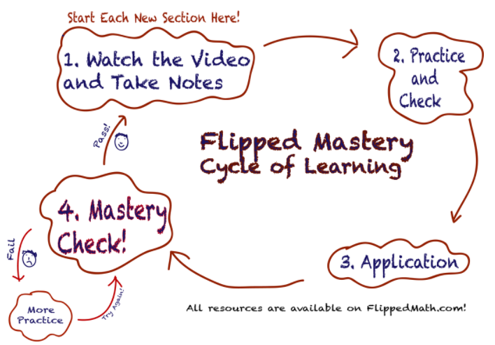
Flipped Classroom: This year we will be following a flipped classroom format. Learners are expected to watch and take notes on assigned videos at home prior to class. Class time will be used to discuss, explore, complete activities, take quizzes, and practice.
Please note: learners who skip videos and do not do all the problems will probably not get a 3 or higher on the AP test.
"There are no secrets to success.
It is the result of preparation, hard work, and learning from failure."
Colin Powell
Attendance: Learners are expected to attend class. https://marktomforde.com/academic/undergraduates/AttendingClass.html
Class meets on Monday, Wednesday, and Thursday (Red Block). Learners are more than welcome to come in during Bobcat Time (Period 0) from 2:00-2:30 pm, if needed.
Handbook attendance policies apply. If a learner is absent, they are still responsible to do all of the class work. Assignments and links to videos will be posted on either Canvas and/or Mrs. Zubke’s webpage.
Daily Work: Homework will consist of content videos that the learners should watch, take notes, and work through the practice problems. Other homework will consist of AP Classroom Topic Questions (usually MCQ) and other materials that are not completed in class. Class time will be used to discuss, explore, complete activities, take quizzes, and practice.
Assessments: Assessments will be in the form of the Personal Progress Checks – MCQs and FRQs given at the end of each unit. I would advise getting a notebook/folder/binder specifically for putting Personal Progress Check problems and information. It will be nice to have these all in one place. Additional assessments may be added, as necessary.
Group Work: There will be ample opportunities to complete group activities throughout the lessons (for example, quick review questions before each section and explorations). The formation of study groups is encouraged. Be careful that you are using your groups correctly. Working in a group DOES NOT mean that one person does the work and the others copy it. If it is an activity or an exploration, each learner is expected to contribute and actively participate in order to benefit and learn from the activity. Likewise, since homework is not graded, there is nothing wrong with working with other learners. However, when homework is done in a group, ideally each learner does the problem and then the answers are compared. It does not mean that the problems are divided amongst the group. If the answers do not agree, the group should discuss and come to a consensus as to the correct answer and what the errors were in the incorrect answers. Groups need to be used to maximize learning NOT to minimize effort.
Late Work: Learners are expected to turn in assignments during class on the day that they are due. Late work will be deducted 20% for each day it is late (ex. 2 pts per day for a 10 pt assignment). When a learner is absent, they will have an additional day to get their work in. For example, if a learner is gone on Tuesday, the work they had that was due Tuesday should be in by Wednesday. The work assigned on Tuesday to be due Wednesday should be in by Friday. Work turned in after this day will be deducted 20% for each additional day it is late.
Missed Personal Progress Checks will not be accepted if late. When setting up the due dates for Personal Progress Checks adequate (abundant) time is given. The MCQ parts are assigned and answered on the computer. The computer will shut down the turn-in ability at the due date time and the learner will get a zero on that assignment.
Extended absences will be dealt with on a case-by case basis. Learners will generally get one more day than the number of days they were gone to get their work in. For example, if they missed three school days, they will have four school days to get caught up.
Calculators: Graphing calculators will be used regularly. Learners are required to have their own graphing calculators. TI-84 plus calculators are recommended, but any grapher will work. The instructor will be utilizing a TI-84 plus CE. One-third of the questions on the AP test require the use of a graphing calculator.
Communication of Mathematics: Learners will be communicating mathematics and explaining solutions both verbally and in written sentences. All written work is expected to be mathematically accurate and of high quality.
AP Test: The AP test this year will be on Monday, May 8th. Learners will need to bring a graphing calculator. There is an acceptable calculator list at AP Central. The test generally consists of two sections: Multiple Choice questions are worth 1.2 points each. 15 calculator – 30 minutes and 30 non-calculator – 60 minutes. Free-Response questions (FRQs) are worth 9 points each. 2 calculator – 30 minutes and 4 non-calculator – 60 minutes. More discussion on the AP Test will take place in class later.
College Board Site: Learners will create an account at https://account.collegeboard.org/login/signUp
(If they have previously taken an AP test, they already have an account.) They can get a lot of information about AP courses and testing at that site. They will also need an account here to get their results. I believe this is also the location where they will be signing into AP Classroom. This is where I will be assigning Daily Videos, Topic Questions, and Personal Progress Checks as we go through the course.
Percent | Mark | AP Course Grade Point
98-100 | A+ | 5.00
95-97 | A | 5.00
92-94 | A- | 4.67
89-91 | B+ | 4.33
86-88 | B | 4.00
83-85 | B- | 3.67
80-82 | C+ | 3.33
77-79 | C | 3.00
74-76 | C- | 2.67
71-73 | D+ | 2.33
68-70 | D | 2.00
65-67 | D- | 1.67
Below 65 | F | 0.00
Grading Scale: as posted to the right
Grading Policies: Grades will be determined based on total points.
Mrs. Zubke’s website: https://pz010.k12.sd.us
The teacher reserves the right to adjust this syllabus as needed throughout the school year. Learners will be notified of changes.

