Geometry A Syllabus Instructor: Mrs. Zubke
Brookings High School 2023-2024
Course Description:
Geometry courses, emphasizing an abstract, formal approach to the study of geometry, typically include topics such as properties of plane and solid figures; deductive methods of reasoning and use of logic; geometry as an axiomatic system including the study of postulates, theorems, and formal proofs; concepts of congruence, similarity, parallelism, perpendicularity, and proportion; and rules of angle measurement in triangles.
Class information/links will be located on Canvas and pz010.k12.sd.us (click the Geometry A link to go to the course page.)
Course Outline:
- Solving Algebraic Linear Equations - Review
- Module 1: Reasoning with Shapes
  - Module: Ready Check
  - Topic 1: Using a Coordinate Rectangular Coordinate System
    - 7 Problem Sets
    - Mixed Practice (Spaced and End-of-Topic Review)
    - Topic Assessment
  - Topic 2: Rigid Motions on a Plane
    - 5 Problem Sets
    - Mixed Practice (Spaced and End-of-Topic Review)
    - Topic Assessment
  - Topic 3: Congruence Through Transformations
    - 3 Problem Sets
    - Mixed Practice (Spaced and End-of-Topic Review)
    - Topic Assessment
- Module 2: Establishing Proof
  - Module: Ready Check
  - Part 1: Triangles and Other Polygons
    - 3 Problem Sets: Topic 1: Set 5; Topic 2: Sets 3 and 4
    - Part 1: Review
    - Part 1: Assessment
  - Part 2: Circles
    - Topic 1: Set 1: Topic 2: Set 5: Topic 3: Sets 3 and 1
    - Part 2: Review
    - Part 2: Assessment
- Module 3: Investigating Proportionality
  - Module: Ready Check
  - Topic 1: Similarity
    - 6 Problem Sets: 1-3, 5-7
    - Mixed Practice (Spaced and End-of-Topic Review)
    - Topic Assessment
  - Topic 2: Trigonometry
    - 12 Problem Sets
    - Mixed Practice (Spaced and End-of-Topic Review)
    - Topic Assessment
- Module 4: Connecting Geometric and Algebraic Descriptions
  - Module: Ready Check
  - Topic 1: Circles and Volume
    - 6 Problem Sets
    - Mixed Practice (Spaced and End-of-Topic Review)
    - Topic Assessment
  - Topic 2: Conic Sections -
    - 5 Problem Sets
    - Mixed Practice (Spaced and End-of-Topic Review)
  - Module Assessment
- Module 5: Making Informed Decisions
  - Module: Ready Check
  - Topic 1: Independence and Conditional Probability
    - 8 Problem Sets
    - Mixed Practice (Spaced and End-of-Topic Review)
  - Topic 2: Computing Probabilities
    - 5 Problem Sets
    - Mixed Practice (Spaced and End-of-Topic Review)
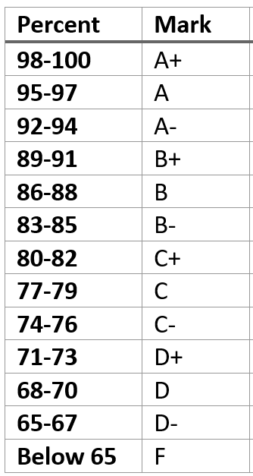
Grading:
Grades will be determined based on total points. Not everything that is done in class is graded. Items that may be graded include quizzes, tests, activities, etc.
Late work:
It is imperative that learners stay caught up on their work. If they fall behind, their scores will reflect. If there is missing work, students should come in during Bobcat Time on Tuesdays and Fridays from 2:00 – 3:25 pm to get caught up.
Attendance:
Learners are expected to attend class. If a student is absent, they need to find a friend get information on the material that they miss (I will try to have all handouts available on CANVAS). They can also come in during Bobcat Time on Tuesdays and Fridays from 2:00 – 3:25 pm to get caught up.
Calculators:
Learners will find calculators useful. They are expected to have their own scientific calculators (need to be able to do trig functions – SIN, COS, TAN); they do not need to be fancy. They CANNOT use the calculators on their phones as CELL PHONES ARE NOT ALLOWED IN THE CLASSROOM.
Other supplies:
The only book we will use is a Skills Practice consumable book. They get one for the entire year. Do not lose it! Learners will want a folder to keep their notes in. They will get a note guide for each lesson. They may find having their own ruler, compass, and protractor helpful, however, there will be some available in the classroom for use.

This syllabus may need to be adjusted throughout the school year.
Students will be notified of changes.

